ANNUAL REPORT FROM THE PRESIDENT FOR 2018
You will remember several years ago when the Queen announced to the world that she had had an annus horribilis. As President of PICS I can announce with confidence and pride that the Society has just experienced an annus memorabilis.
2018 had all the ingredients for a memorable year and we were not disappointed. It was of course, the 50th Anniversary of the formation of PICS and the 150th since the Land Ballot of Phillip Island. Members marched proudly with the Society Banner in the Community Street Parade in early November to a packed, enthusiastic crowd in Thompson Avenue.
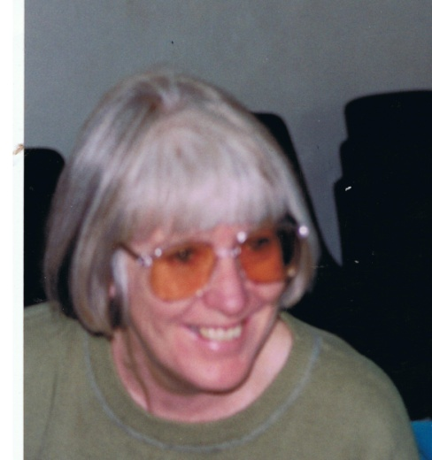
To commemorate the Society’s significant year in its history, the book Women in Conservation on Phillip Island was launched. It acknowledges that the many generations of women and the families of the First People respected the Island when they visited in the summer months and left a soft footprint. Christine Grayden edited the book and we are most grateful for her commitment to the project and the many hours she generously contributed to its publication. The book was launched at an afternoon event in the Cultural Centre in March and many of the contributors and their families were present. Marg Johnson, who was the dedicated Society Secretary during the tumultuous years of Island development pressure, was able to contribute and enjoy the book before sadly passing away in February. She will be forever remembered. The book was included in the nominations for this year’s Victorian Community History Awards.
A proposed Vehicular Ferry Terminal in Cowes was the Island’s most controversial planning issue for the year. And as is the Society’s usual response to significant proposals, we held a Public Meeting in the Parish Hall in March and a capacity crowd poured in the door. It was very pleasing that a new generation of Island residents wanted to be actively involved. A Ferry sub-committee was formed and Jane Jobe elected as its Chair. Jane submitted a great response to Council on the flawed Business Plan on behalf of the Society. The Council rejected the Ferry proposal and now once again it is a wait and see game.
This year Sunday afternoon general meetings were trialled in the Cultural Centre. These have worked well and will be continued this year. A variety of Speakers have been interesting and informative.
I have represented PICS on the Totally Renewable Phillip Island 2030 Working Group. This is an exciting, motivated group that are highly skilled and informed and have already been successful in obtaining significant grants. I also represented the Society on the PINP’s 30Year Conservation Plan Working Group, the Phillip Island/San Remo Visitor Economy Strategy and the PINP Environment and Community Advisory Group. Phil Wright has been the Society’s rep on the Bass Coast Council Environment Advisory Group and Pauline Taylor is the rep on Friends of Churchill Island Society.
Margaret Hancock is our Planning Guru and ably supported by Penny Manning. The most recent appearance at a Planning Panel Hearing was in November in Cowes when decisions were sought to introduce proposals to the Planning Scheme that arose as a result of the Cowes Activity Plan. The amendment is C151.
Penny chairs the committee meetings, the first Saturday of the month. Penny, Margaret and I continue to meet with the Bass Coast Planners during the year. It will be necessary to talk with them about the new State “Distinctive Areas and Landscapes” inclusion in the Bass Coast Planning Scheme.
As a result of committee members Jeff Nottle and Lisa Schonberg’s ongoing friendship and interaction with the Sea Shepherd through the Preserve Westernport Campaign, some members joined them at a remarkable day at the Astor Theatre in Windsor in September. The event featured films showing Sea Shepherd’s dedicated role as the ocean’s policemen and women. We all came away inspired and grateful for the opportunity to witness strong environmental action at work!
The concern about the threat of industrialisation of Western Port is constant and PICS will always be a strong voice for the maintenance of the Bay’s integrity. The AGL Gas Import Project at Crib Point and the connecting pipeline to Pakenham issue is gaining momentum. The fact that it appears to have the support of the 2 major Victorian State political parties is of great concern. Jane Jobe, on behalf of PICS, has submitted a comprehensive and informed response to the government’s decision to require an EES on the proposal. Thank you again Jane.
In September PICS city and local members gathered in the Cultural Centre to acknowledge and celebrate PICS fiftieth birthday. John and Christine had put up Displays and we were very pleased that 5 Bass Coast Councillors joined us. It was a wonderful 2 hours of happily reminiscing about the campaigns and the lobbying the Society and members had been involved in over so many years and in different ways.
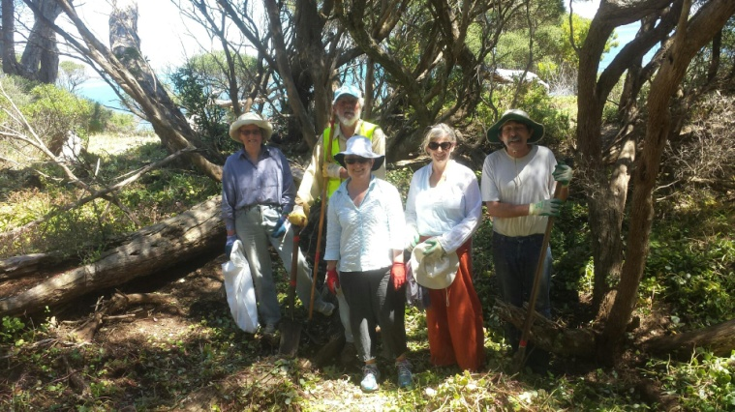
As 2018 was a significant milestone in the history of PICS, Vice-president Jeff Nottle flagged the idea of a Planning Day for the Society as it moves into its next 50 years. An enthusiastic attendance of 18 members attended a session in the Cowes Cultural Centre in November. It was great that long-time member and ardent PICS supporter Greg Johnson agreed to facilitate the session. Jeff will present the Report on the Planning Day shortly.
Our thanks to John Eddy for his commitment to CoastCare and the good news story that is the restoration work that has occurred at Scenic Estate Reserve with our Friends group. And of course John's role assisting Christine with the excellent, informative PICS Newsletter.
After 7 years, I think, of being the President of the Phillip island Conservation Society, it is time to pass the Baton. Jeff Nottle has agreed to be the incoming President and I am confident the Society is in a safe pair of hands.
It has been a privilege to have served in the role and an honour I will always treasure.
My grateful thanks to the dedicated PICS committee. They are a capable and knowledgeable team who share the passion for the Island’s wellbeing. The committee values the ongoing support of members and urges them to continue the support and to encourage others to join. We are grateful for the assistance Matt Ingham has given Christine this year.
Christine’s annual Children’s Environment Day, “Animals of Oz”, was held in Cowes this morning. It is supported by the Bass Coast Council.
Christine is the glue that holds it all together and on your behalf I want to say we are indebted to her for her commitment and work for the Society. How I wish that someone can put up their hand to ease her workload as Treasurer and Secretary
Over 50 years the Phillip Island Conservation Society has, by providing responsible leadership, gained the respect of the local community and local and state governments.
I am confident that this will continue as the Island faces the challenges of the future. Phillip Island will always need the strong voice of PICS. Anne Davie
PRESERVE WESTERN PORT ACTION GROUP (PWP)
A key highlight was the launch of the history of Preserve Western Port Action Group (PWP) Campaign written by Phyllis Papps. The history provided an excellent outline of the campaign resulting in a “Glorious Win” in May 2017 when Infrastructure Victoria opted for Bay West in Port Phillip for the second container port for Victoria, not the Port of Hastings.
The history Foreword was written by the Bass Coast Mayor Cr Pamela Rothfield who stated: “What a debt of gratitude, we the residents of Phillip Island and waterline towns owe to the Preserve Western Port Action Group”.
This year has also seen other attempts to industrialise by the gas industry and the State and Federal Governments. PWP and PICS have been active in developing partnerships to express concerns about the AGL proposal to process LNG gas in Western Port. We have made submissions to State and Federal Governments seeking greater environmental scrutiny. Both initiatives have been successful and State EES and Federal EPBC examinations will be undertaken. Jeff Nottle
RED ROCKS COASTCARE
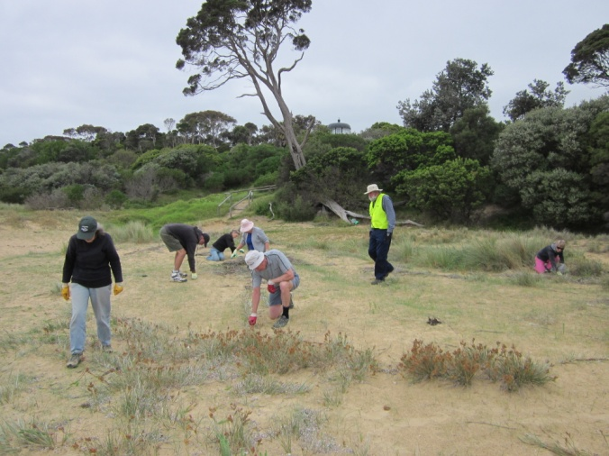
Due to other commitments, I have had to put normal activities at Red Rocks on hold this year. However, we did run a working bee in March to clean up rubbish and old plant guards, with 9 volunteers attending. In August, a small group of volunteers put in 74 plants.
Sea Spurge continued to be monitored and removed regularly, and is now emerging in very low numbers. That is a great outcome. I have done Blue Periwinkle “search and destroy” missions several times during the year, and we have 3 “hotspots” for that persistent weed which require spraying by Shire contractors.
As usual, special thanks to the Shire’s Natural Resources Officer, Dave Martin, and, in his Long Service Leave absence, Adam Johns, for their great support and encouragement during the year.
John Eddy. RRCC coordinator 14.12.2018

SALTWATER CREEK COASTCARE
This group has been inactive during the year, as coordinator Kevin Harris has been pre-occupied with on-going commitments in Melbourne. He hopes to spend more time on the Island next year. Most plants put in over the past 3 or 4 years continue to do fairly well, with wallaby guards generally effective. John Eddy
FRIENDS OF SCENIC ESTATE RESERVE
The Friends of Scenic Estate Reserve held 6 working bees during the year, with volunteer attendances of 7, 6, 14, 6, 6 and 9 respectively. Weed control, rubbish clean-up and planting were again the main activities, and, of course, morning tea! In addition, a number of smaller activities, involving just 1 or 2 volunteers, took place. FOSER sincerely thanks all its volunteers and gratefully acknowledges their on-going support. Special thanks to Kate McLaughlin for always supplying the hot water and cups.
Over the two planting days in June and July, a total of 420 plants went in, at 3 sites within the Reserve: the entrance from the carpark, the area in the middle of the Reserve we call “Stinkwort Flats”, and an open area near the coast into which we are hoping to extend the Moonah Woodland. Early indications promise good survival in all 3 areas.
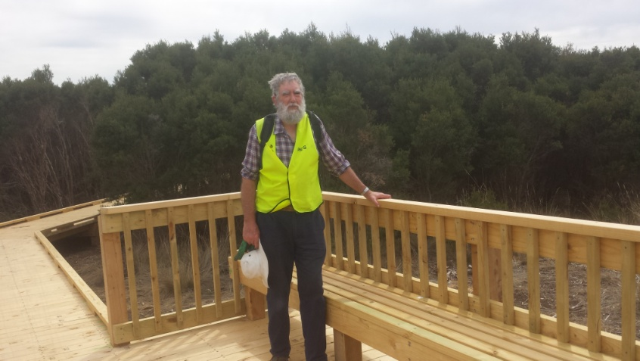
Three weeds have been targeted this year. Stinkwort in the centre of the Reserve has been reduced sufficiently now to make hand-pulling an effective means of control, preventing seed set. Along the old service road to the south, infestations of this free-seeding annual have been dense enough to still require spraying by Shire contractors. The key aim of preventing any seed-set of Stinkwort at all in the Reserve was achieved. Thistles of several sorts have been cut and dabbed, or pulled up, on a regular basis, mostly Spring to Autumn. We concentrate on Gorse in late winter, when flowering makes its presence obvious. Several heavily-infested areas had to be sprayed this year. Less dense infestations have been controlled manually, again by cutting and dabbing with Roundup. Some of our volunteers are reluctant to use Roundup these days, so we need to look for effective alternatives.
A significant outcome for 2018 has been the completion by the Shire and the Nature Parks of Stage 2 of the Development Plan for the Reserve. A new boardwalk through Swamp Scrub and a new viewing platform in the north-west corner of the Reserve have been constructed, with Nature Parks staff doing the construction very capably. Additional pathways to and from this new infrastructure have also been completed.
Interpretative signage has also been installed throughout the Reserve. Seven engraved metal signs covering the key aspects of flora, fauna and history of the Reserve were designed and installed as a collaborative project between BCSC, PINP and FOSER. The large painted sign at the carpark has also been upgraded, as have the numerous directional signs. No doubt this all adds to visitors having a positive experience.
I regret that, due to other commitments, we have only been able to get the FOSER committee together for formal meetings on two occasions during this year. However, most issues that arise are easily dealt with via emails, and conversations during working bees. An on-going issue, still not fully resolved, has been how best to incorporate FOSER into the PINP’s Volunteer Program. This will probably be via an “Access Agreement” for scheduled work on the Nature Parks-controlled foreshore reserve. Insurance cover for our volunteers has been the difficulty, but is probably sorted out now.
Again this year, there have been several unfortunate incidents involving off-leash dogs at the Reserve harassing other visitors and their dogs. Each time, the Shire has been notified, and, for a time, we posted a sign at the entrance re-enforcing that dogs must always be on a leash.
We continue to monitor the rate at which Swamp Paperbark is encroaching into the Native Grasslands, and the erosion of the coastal cliffs at the Reserve. Fortunately, we detected no significant encroachment overall, nor change in the coastline for 2018. Special thanks to Phil Wright for helping with these measurements. Botanist Alison Oates and I also monitor changes in 13 plots covering the main plant communities on an annual basis. Again, only minor changes were detected this year, suggesting stable plant communities. Special thanks to Alison for her efforts.
Predictions for 2019 suggest a year that will be significantly drier than normal. Consequently, we are planning to do only minor planting, and will concentrate on weed control, and assessing the success of previous plantings.
As usual, we sincerely thank Bass Coast Shire Council and staff, and the Nature Parks staff, for their support of FOSER , and the work in the Reserve.
John Eddy, FOSER coordinator
FRIENDS OF CHURCHILL ISLAND SOCIETY INC
Unfortunately the planned FOCIS Old Fashioned Picnic did not go ahead due to the one bad day of weather in six weeks – the day of the picnic! Due to a number of factors it proved too difficult to hold on another day, so all of our planning and preparation will have to wait for another year.
FOCIS was successful in gaining $5,000 from a BCSC Community grant to put to the extension of the main shed housing Churchill Island’s collection of historic farm machinery. FOCIS has put a further $10,000 of our own funds towards this project plus over $2,000 from a crowd-funding campaign to put towards signage for the new display of the machinery once the extension is complete in a few months time. PINP is funding the balance for the shed extension.
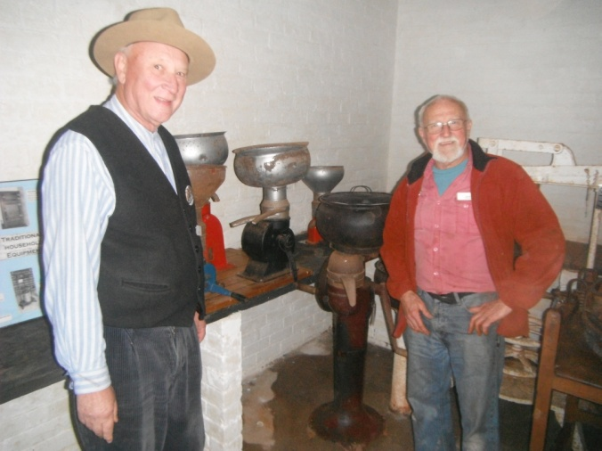
Our curator Christine Grayden retired in July after eight years and has been replaced by Melissa Hayes. Christine continues to organise FOCIS working bees where 6-10 FOCIS members attend to clean the house and cottages or the historic farm machinery several times per year.
Meanwhile our requests to have the gardener’s position made full time to cope with the workload was successful. The gardener Kate is now full time but unfortunately Melissa is only 15 hours per fortnight.
Pat Baird’s wonderful book Churchill Island: History and Her Story is currently on special at 4 copies for $20. These books make excellent gifts and are also a fundraiser for FOCIS. You can buy them from the FOCIS website. Pauline Taylor, PICS representative on FOCIS committee.
PLANNING
2018 saw a sensible outcome to what could have been intensive subdivision on Red Rocks Rd, when the developer agreed to fewer, larger blocks and more tree retention. In the same geographical area, an application for Glamping at Appley Avenue, on the Red Rocks foreshore fire track, was withdrawn after much opposition from local residents and others. This would have been a most unfortunate precedent.
At present we are awaiting the panel report on Amendment C151, Cowes Activity Centre plan implementation. A very interesting two day hearing was held at the Cowes Cultural Centre and many discerning questions were asked by the two members from Planning Panels Victoria. You will find an excellent report of the proceedings in the Phillip Island and San Remo Advertiser of November 21st. An outstanding submission was made by Susan Barclay on behalf of the body corporate of “The Waves” apartments, which included a suggestion that a special historical overlay should be put over Steele Street to protect its particular charm, and to show the importance of guest houses. To me this seemed a very positive suggestions, and one which we all should support. It’s worth taking time just to have a wander in Steele Street and enjoy its ambience and the assortment of trees and gardens leading to Erehwon Point. Hopefully a new architecturally successful “Isle of Wight” will eventuate.
At present there seems to be no positive plans for the Warley Hospital site. And the original intent of the purchase of “Olive Justice Place” seems to have vanished into history! This may have happened because it now seems so long ago – during the time of the shire amalgamation, and the reign of the commissioners. At the Panel hearing I was grateful for Christine’s information about Olive Justice as a real person, who wanted the whole community to benefit from the use of her property – not just a car park! And not a possibly four storey apartment block! We need to come up with some creative suggestions about this rare opportunity to create a special ‘people place’.
The proposed caravan park at Surf Beach is headed for VCAT next year. If you are one of the many people who lodged an objection, please follow it up and appear at the VCAT hearing. Lodging objections is important, but it’s equally important to follow up with the “I wish to be heard”! Margaret Hancock.

